AWS EC2
1)Launch one EC2 using Amazon Linux 2 image and add a script in user data to install Apache.
Open AWS → EC2
1.Click Launch Instance
2.Select Amazon Linux 2
3.Choose t2.micro
4.Create key pair
5.Add user data:
#!/bin/bash
- yum install -y httpd
- systemctl start httpd
- Click Launch
- Copy Public IP
- Open in browser → http://public-ip
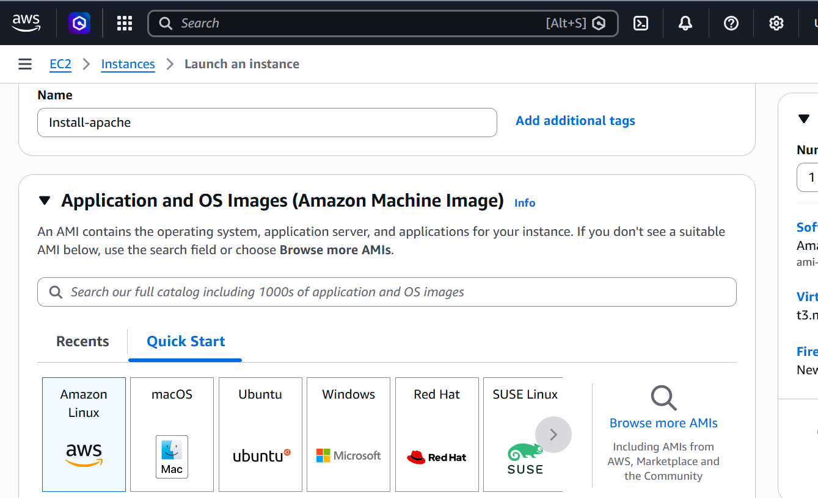
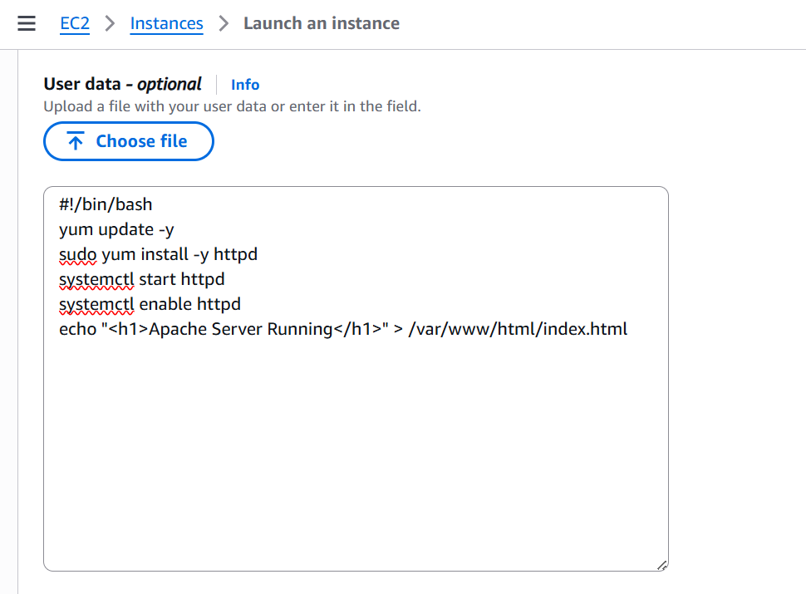
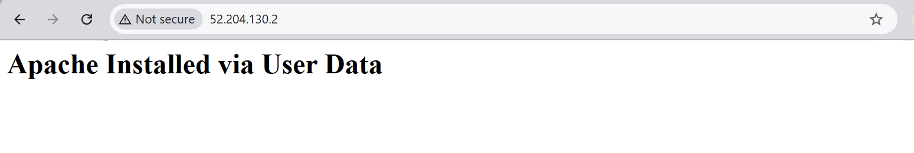
2) Launch one EC2 using Ubuntu image and add a script in user data to install Nginx.\
Open AWS → EC2
Click Launch Instance
Select Ubuntu Server
Choose t2.micro
Create key pair
Add user data:
#!/bin/bash
apt update -y
apt install -y nginx
systemctl start nginx
Click Launch
Copy Public IP
Open in browser → http://public-ip
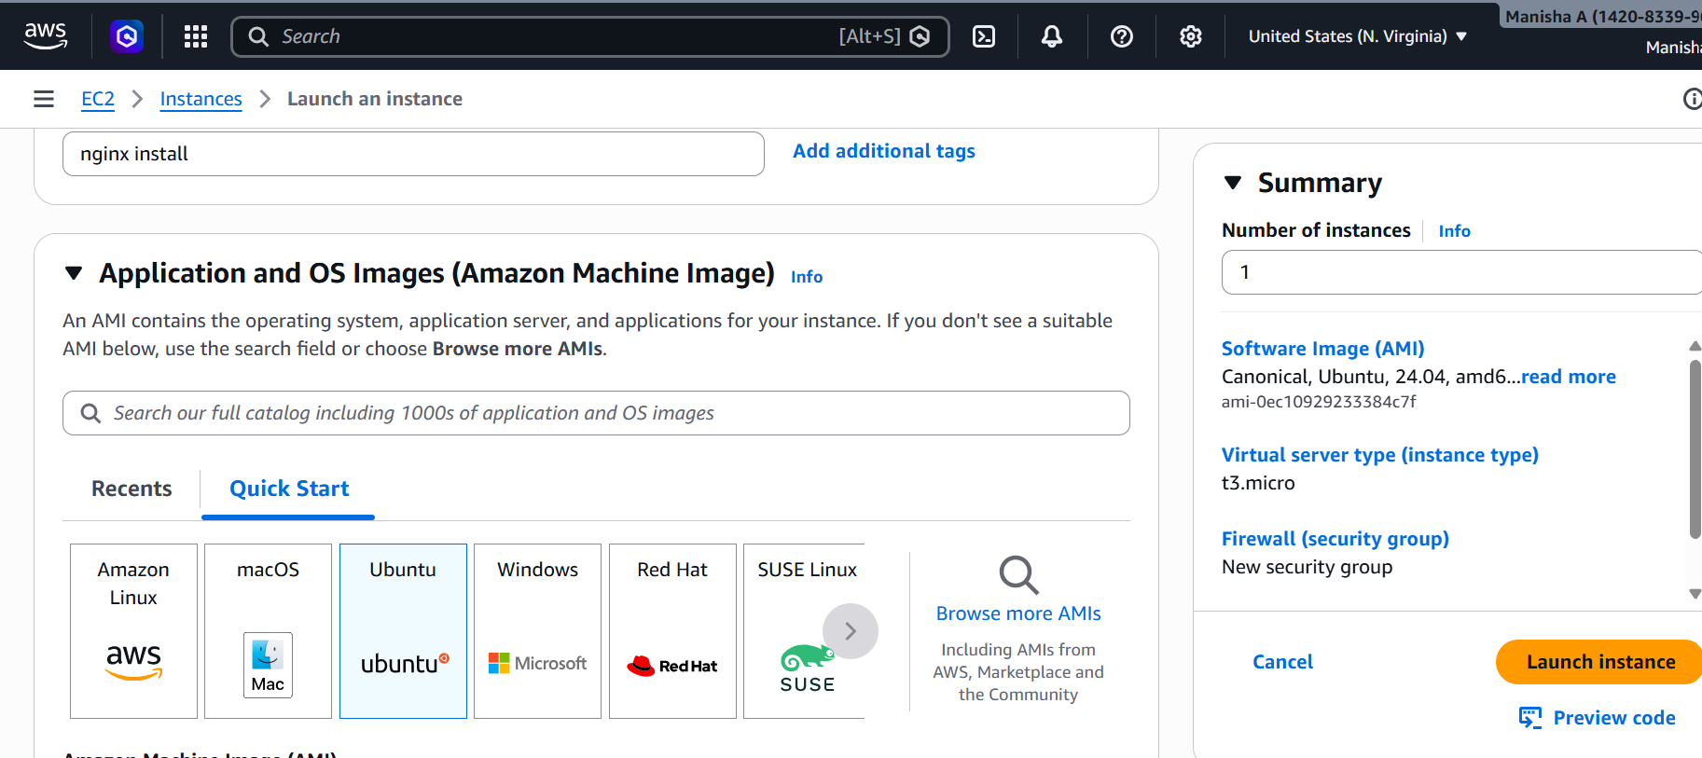
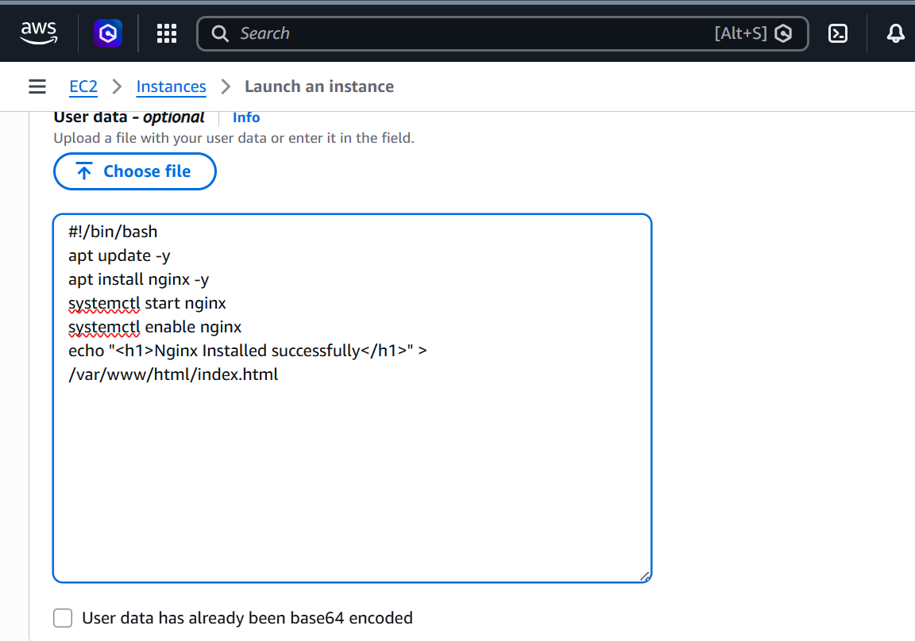
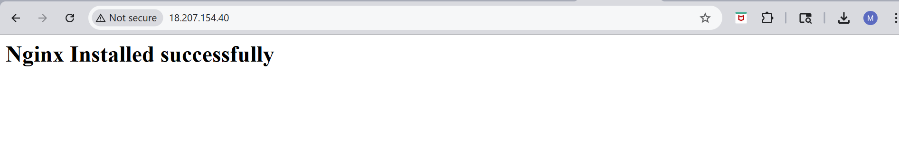
3) Launch one Windows server and install Tomcat on Windows.
Open AWS → EC2
Click Launch Instance
Select Windows Server
Choose t2.micro
Create key pair
Launch instance
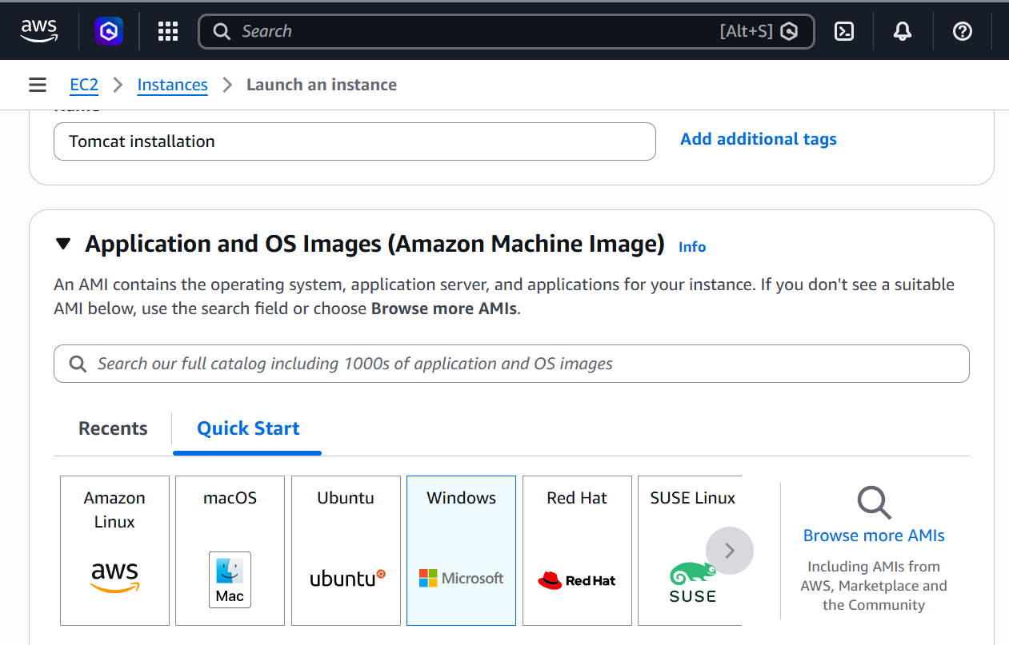
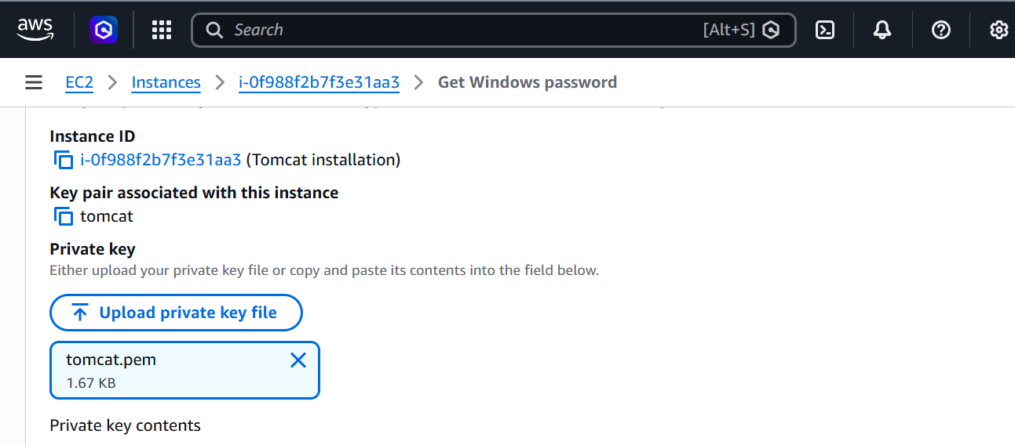

Go to RDP Client
Click Get Password
Upload .pem file
Copy password
Open .rdp file
Login:
Username: Administrator
Password: (copied)

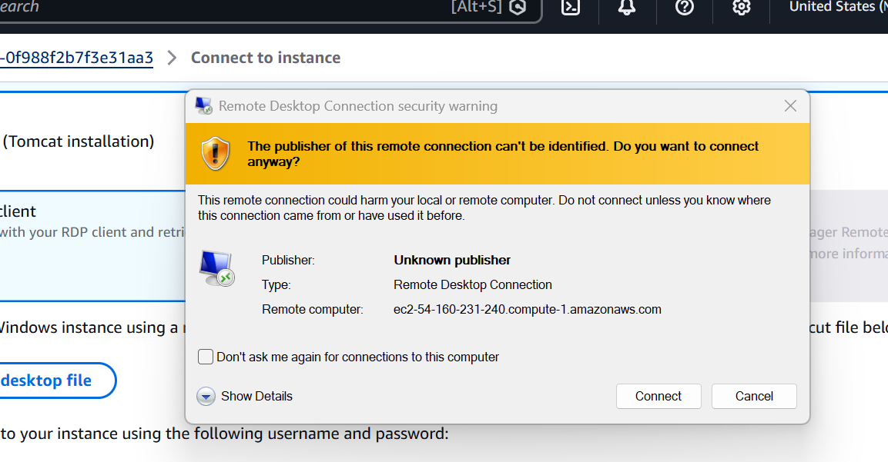
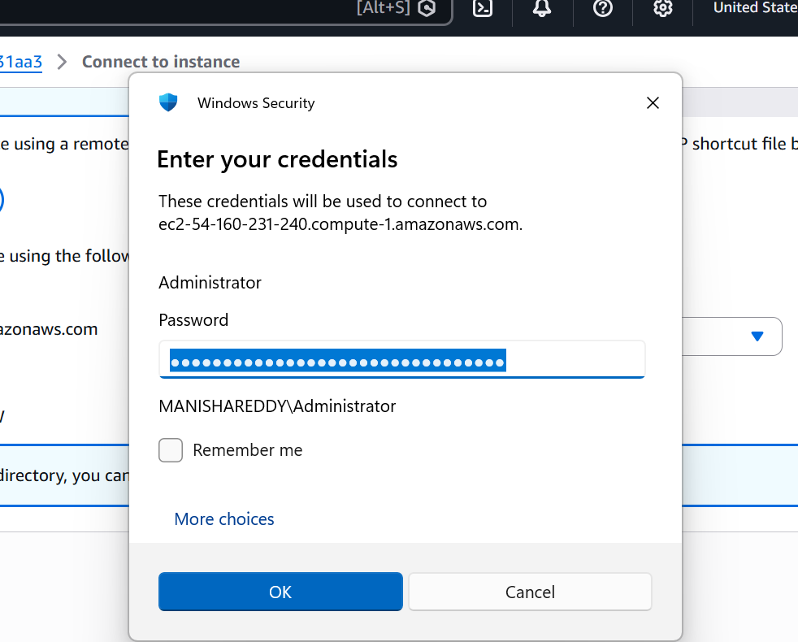
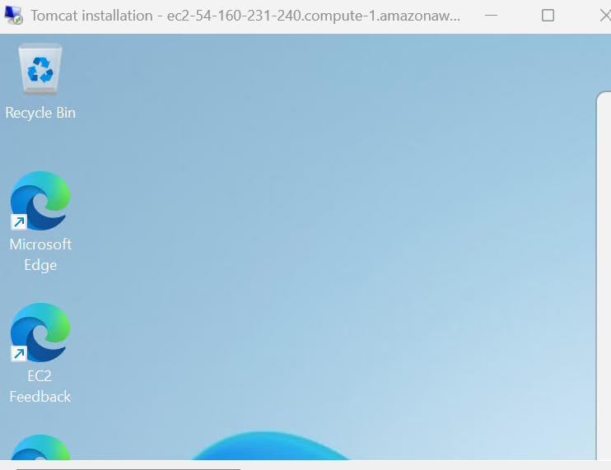
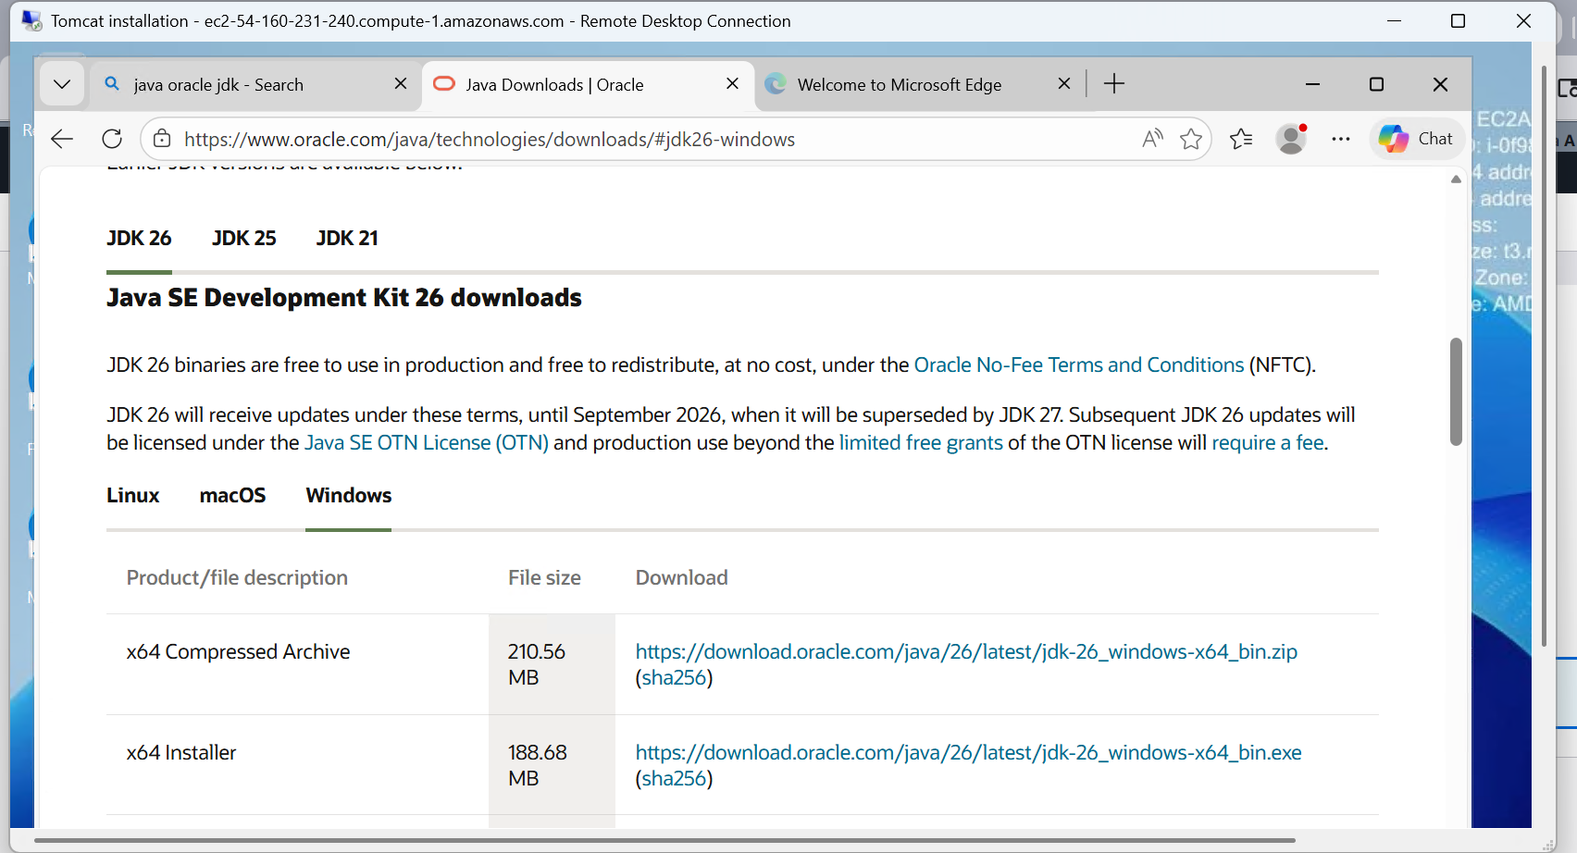
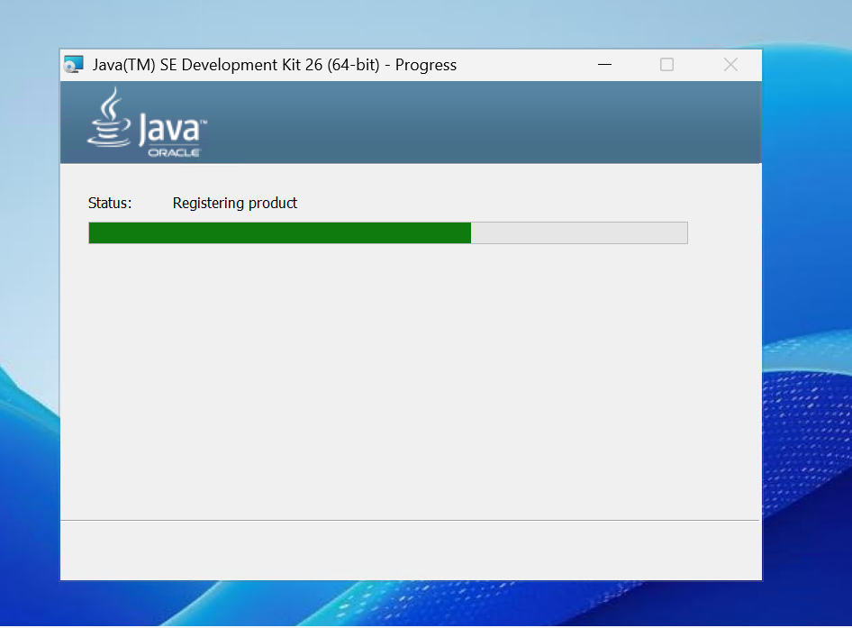
C:\Program Files\Java\jdk-26
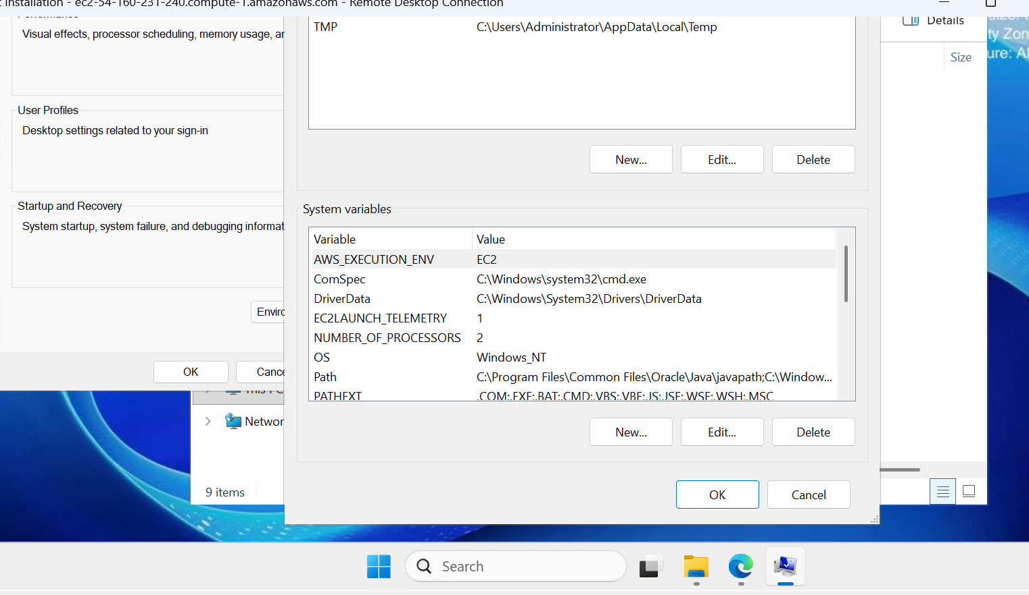
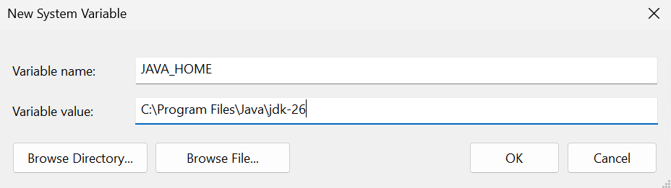
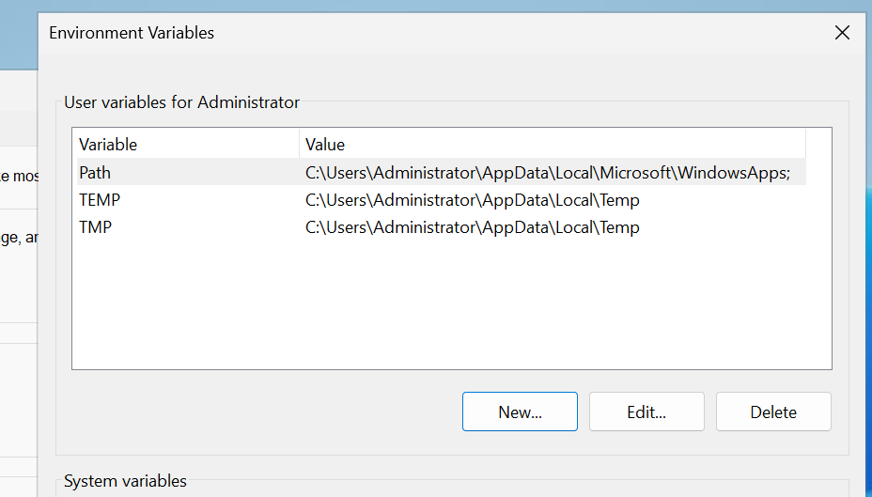
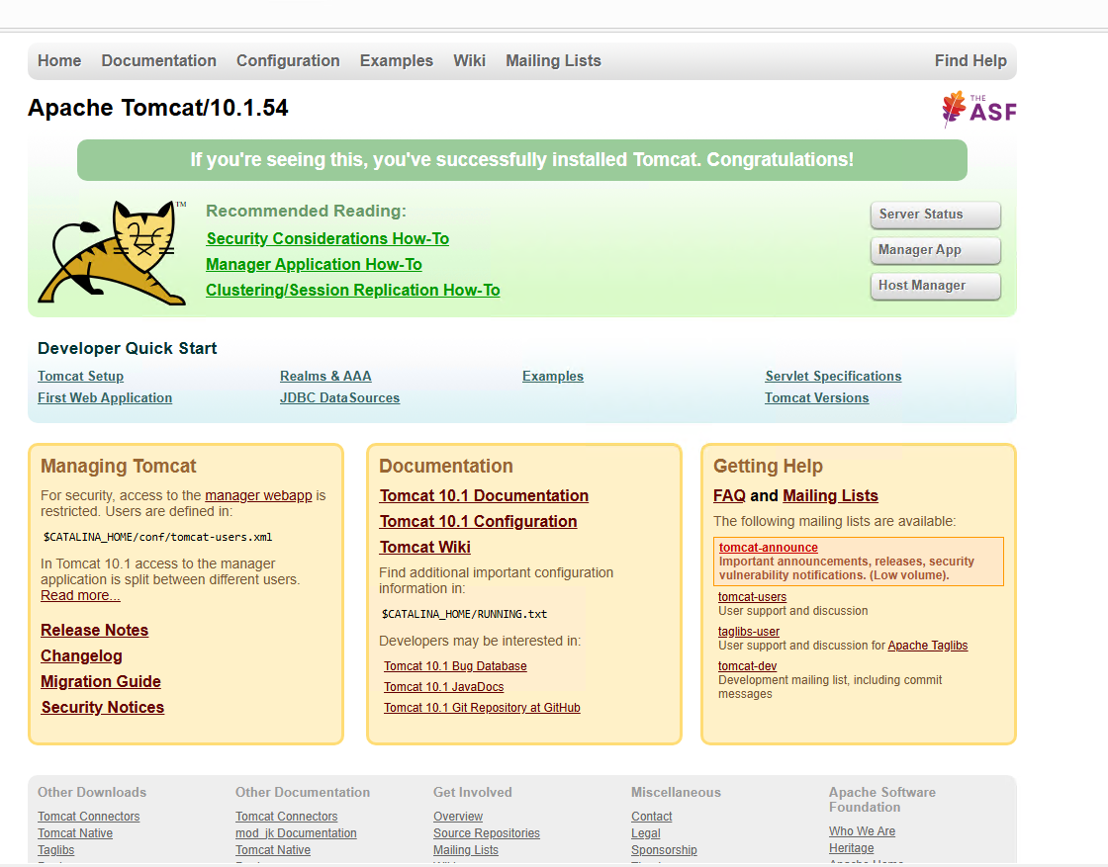
4)Take a snapshot of the instance created in Task 1.
Open AWS → EC2
Click Instances
Select your instance (Task 1)
Click Actions → Create Snapshot
Enter name: my-snapshot
Click Create Snapshot
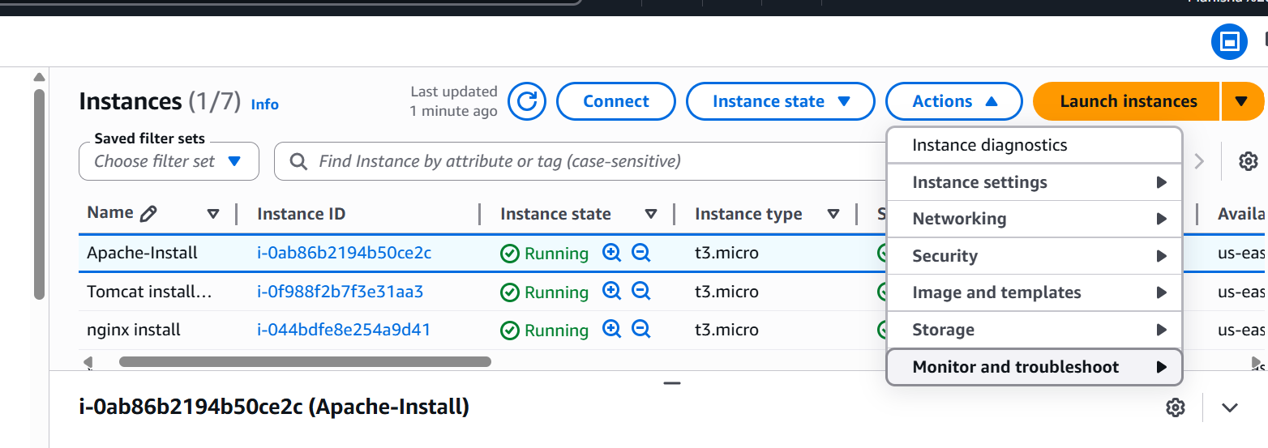
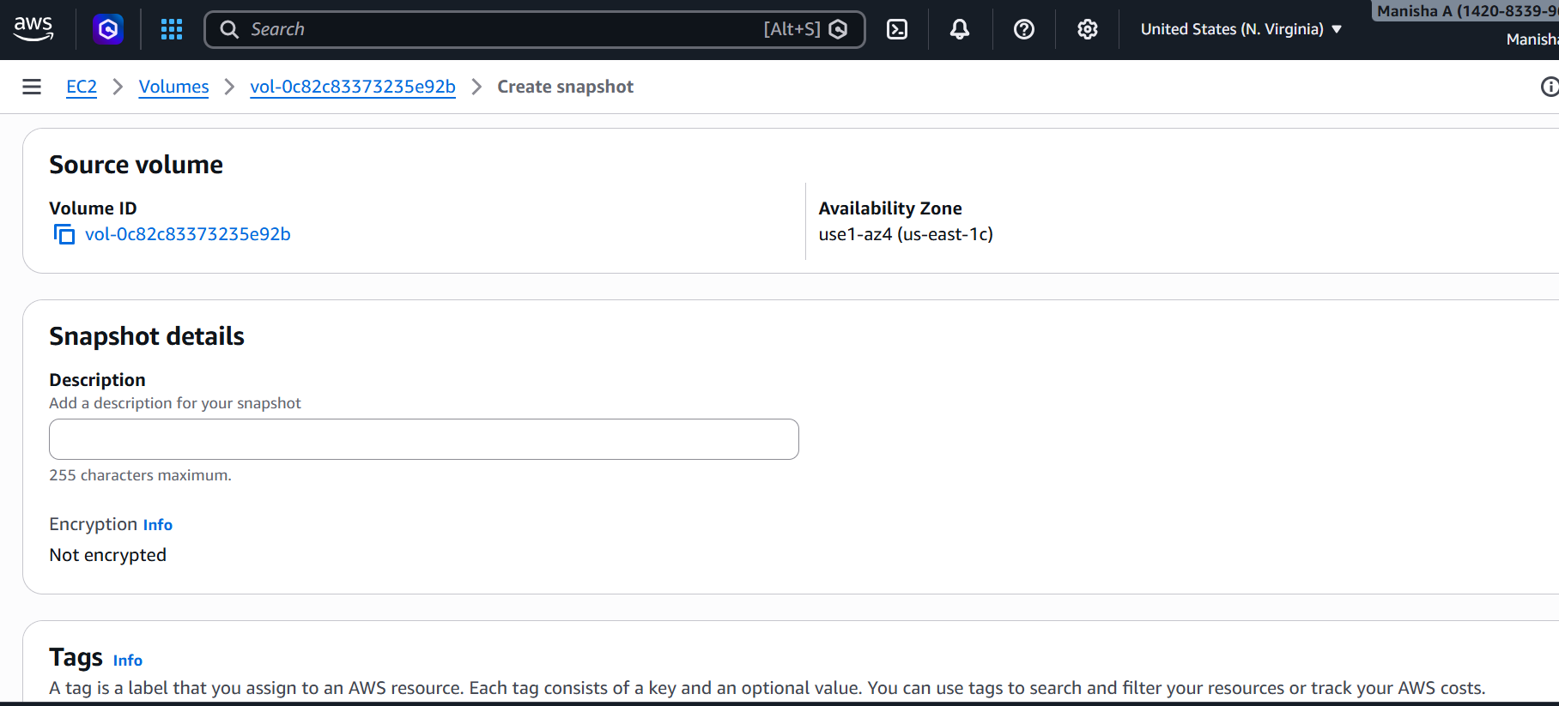
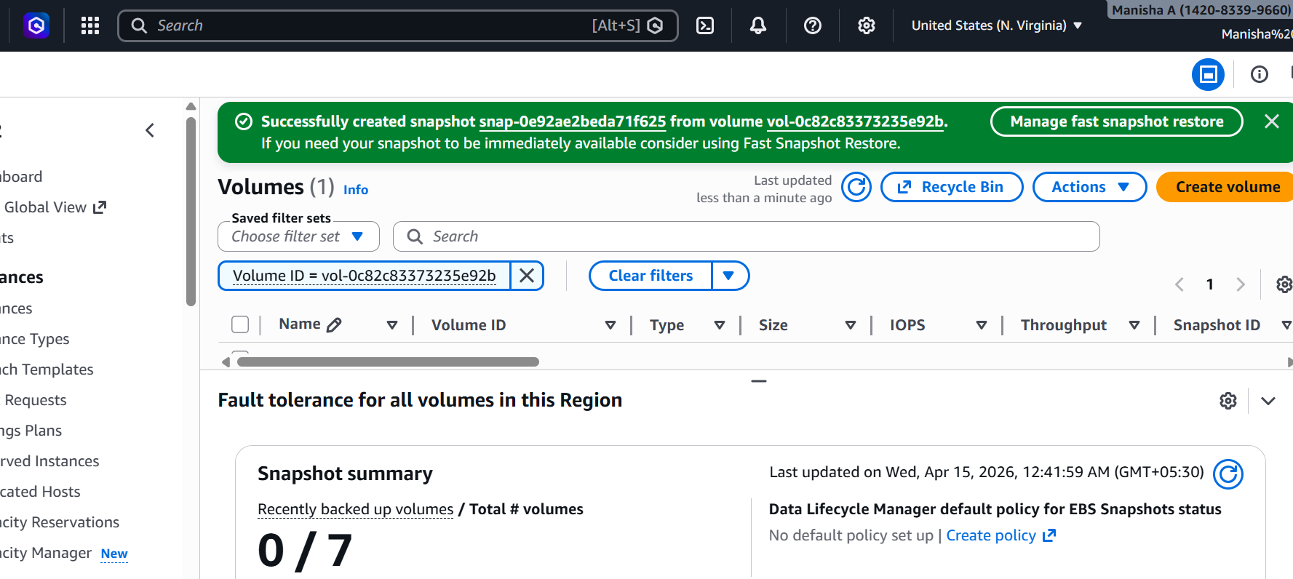
5) Assign passwordless authentication for the EC2 created in Task 2.
Open terminal (local system)
Generate key:
ssh-keygen
Press Enter (default settings)
Copy public key to EC2:

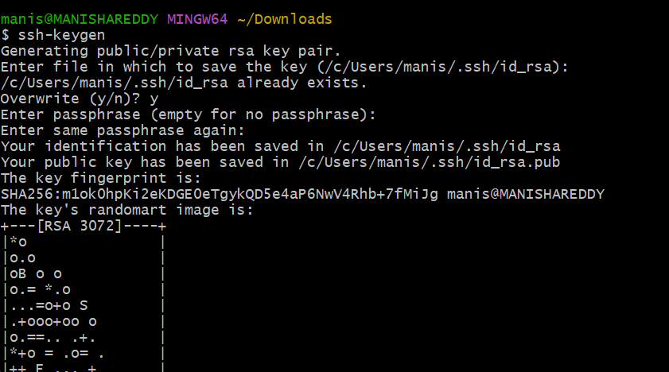

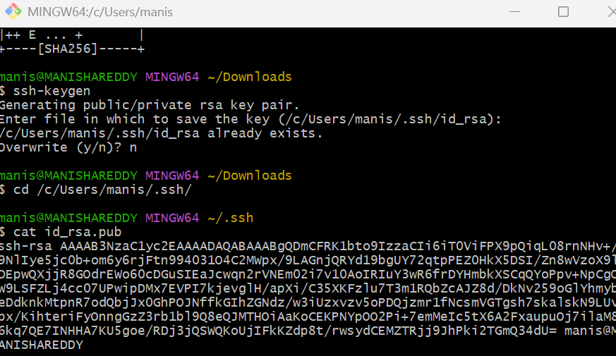
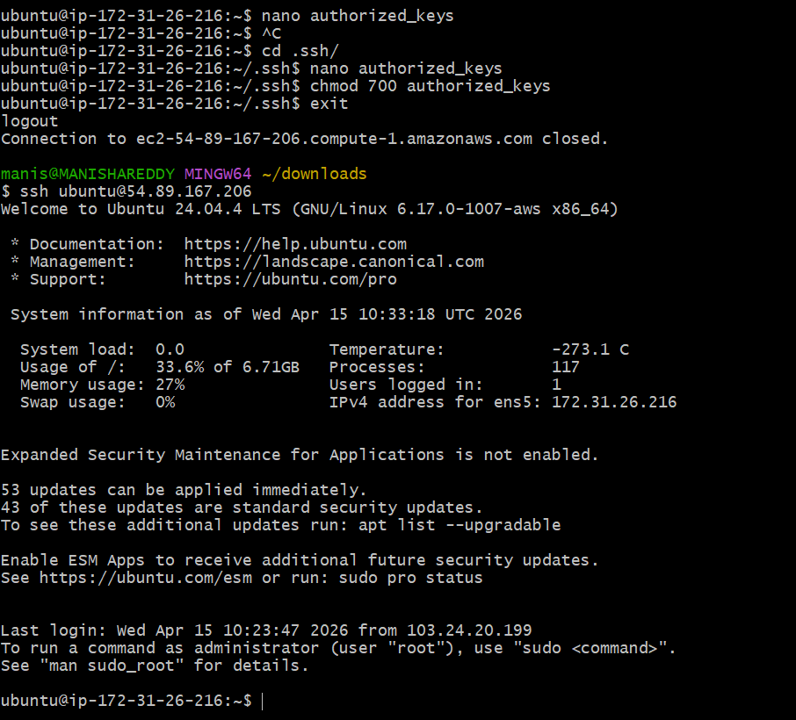
6) Launch any EC2 using the spot purchasing option.
Selected the Spot purchasing option, configured the maximum price and request settings, and proceeded to launch the EC2 instance successfully.

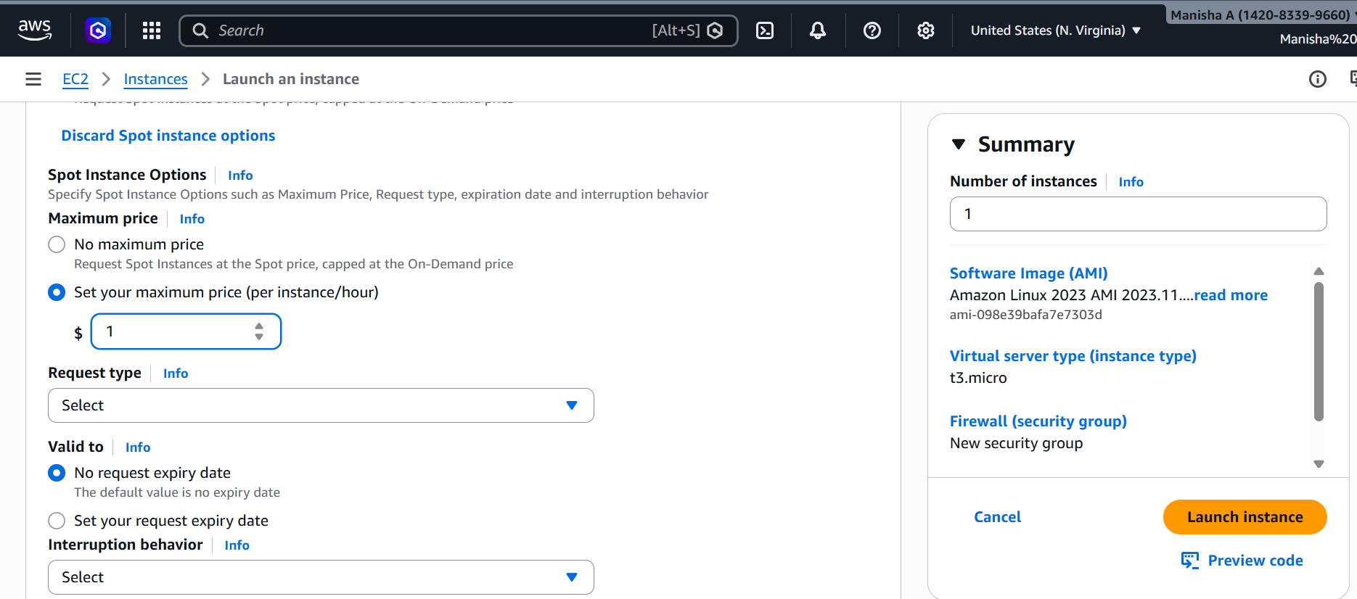
Verified in the Spot Requests section that the Spot EC2 instance request was active and fulfilled successfully.
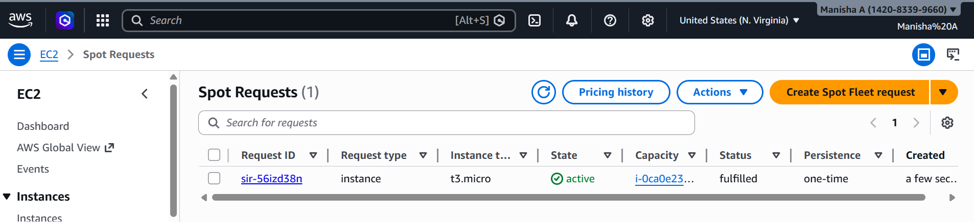

7) Enable termination policy on the EC2 created in Task 2.
Opened the termination protection settings for the Nginx-Server instance, enabled the option, and saved the changes successfully.
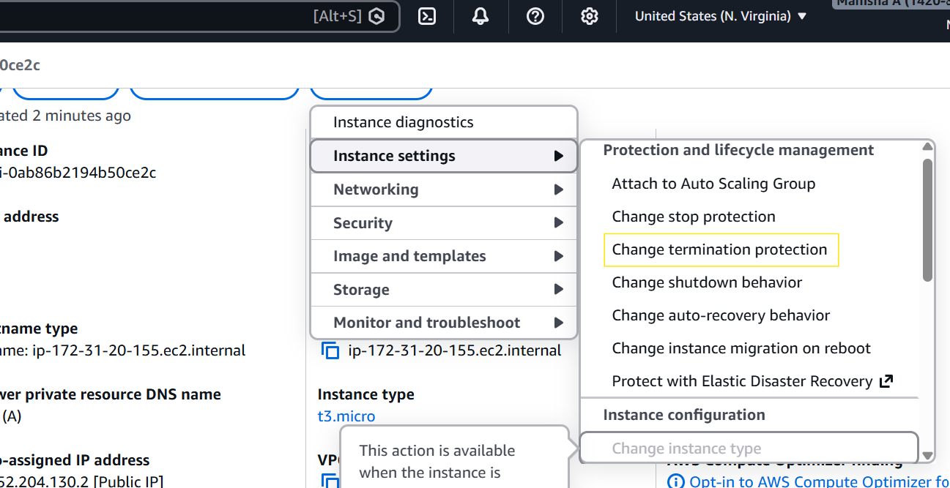

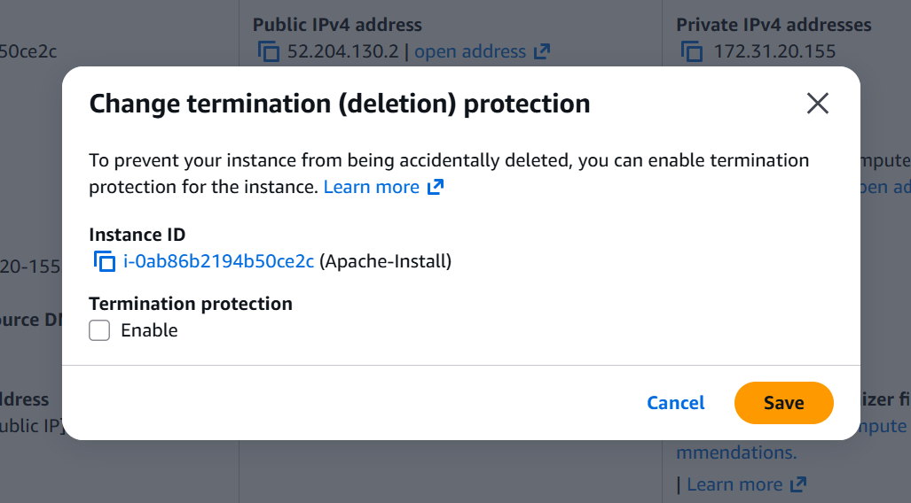
8) Launch one EC2 using AWS CLI.
Aws is configured with my account
Now it has created me the instance

